CPSC 535 8/31/2022

1. Next Monday is Labor Day so no class
2. Function Problem
   1. You have a function and an input so you need to compute F(i) or say can’t do it man
3. Search Problem
   1. Predicate: ??
4. Threshold Problem
   1. Need to find F so that ???
5. Decision Problem
   1. Like threshold but associated with Function and Optimization Problem
6. How to design Algorithms
   1. 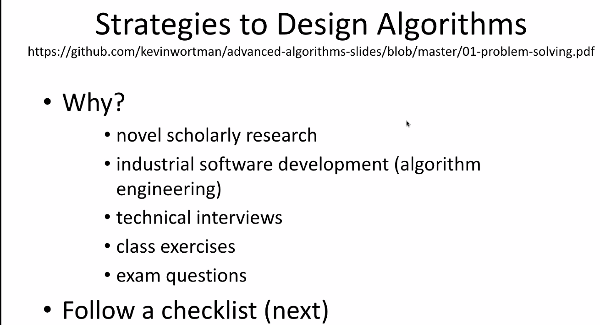
   2. Checklist  
      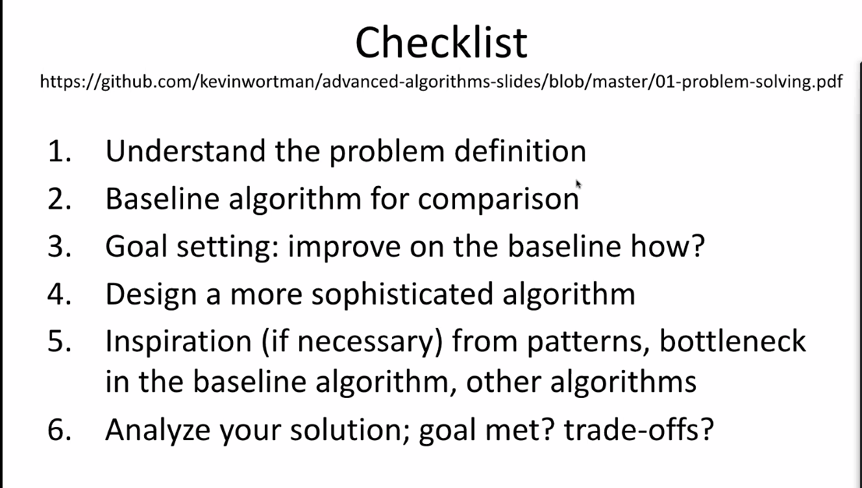
   3. Need to understand problem definition
      1. Need to know input, output, and if output is more complicated how to get there from input
   4. Baseline
      1. A basic algo which you base your complicated algo off of
   5. 1. Understand  
      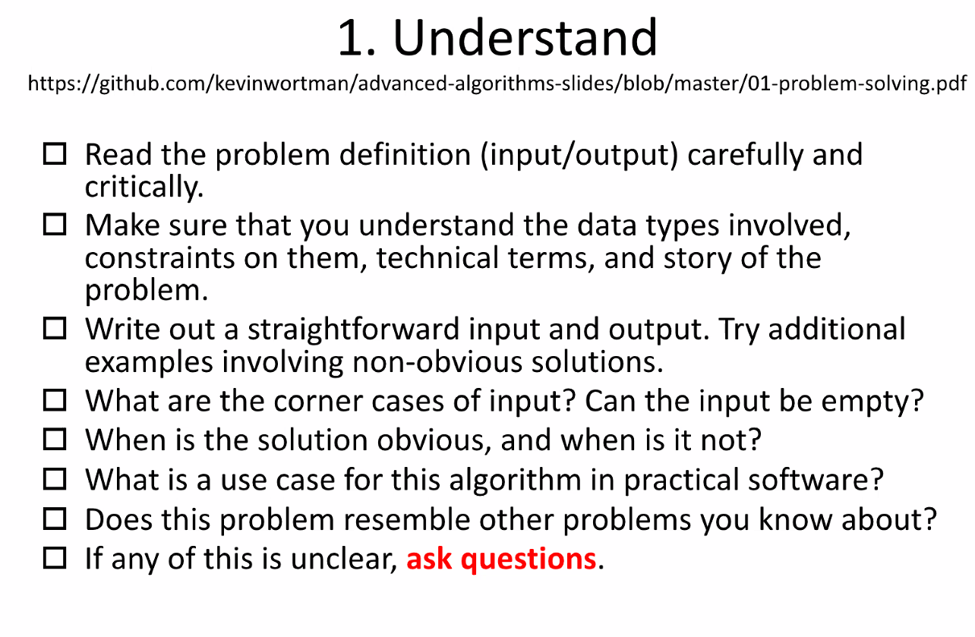
   6. Example Problem: Word Fin  
      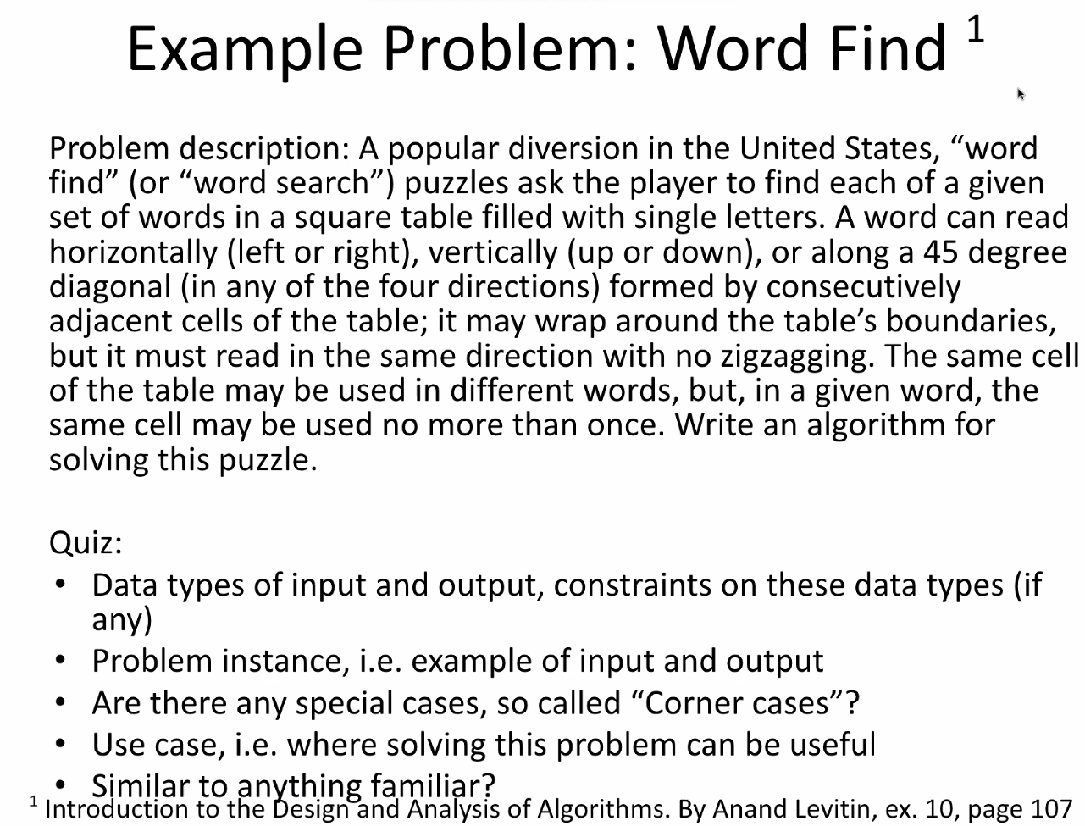
      1. Validate input and output
   7. Baseline  
      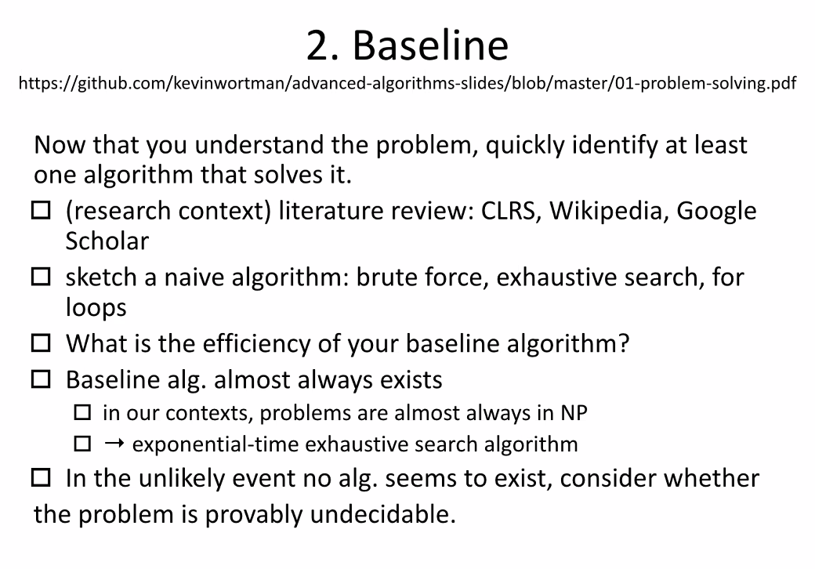
      1. 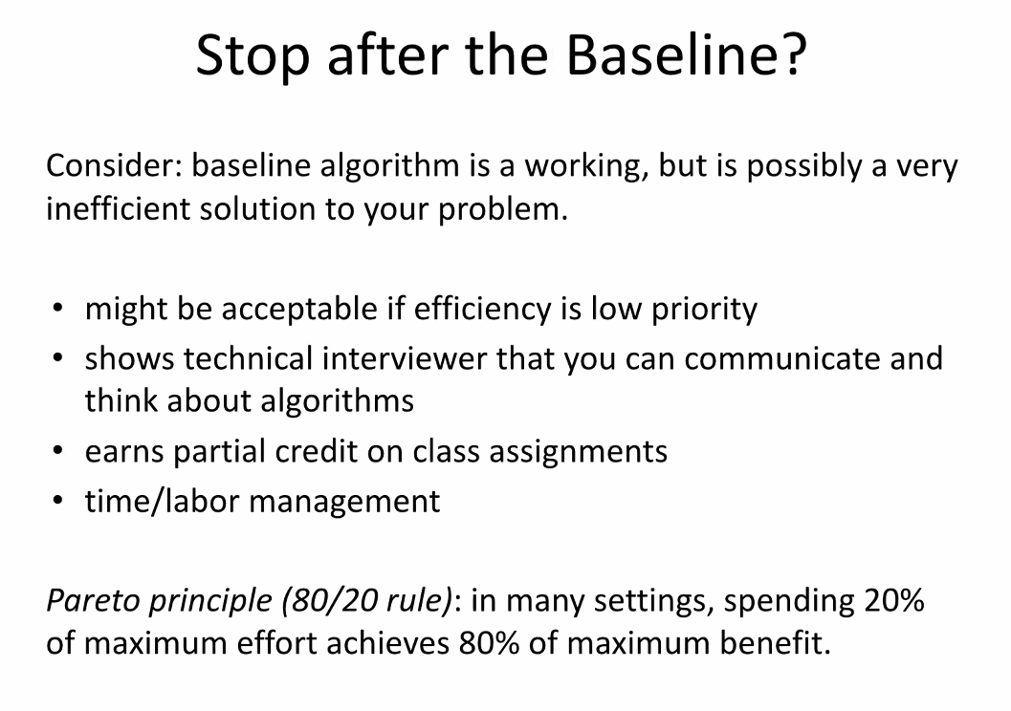
      2. 80% of grade is based off of the baseline algorithm
   8. Goal  
      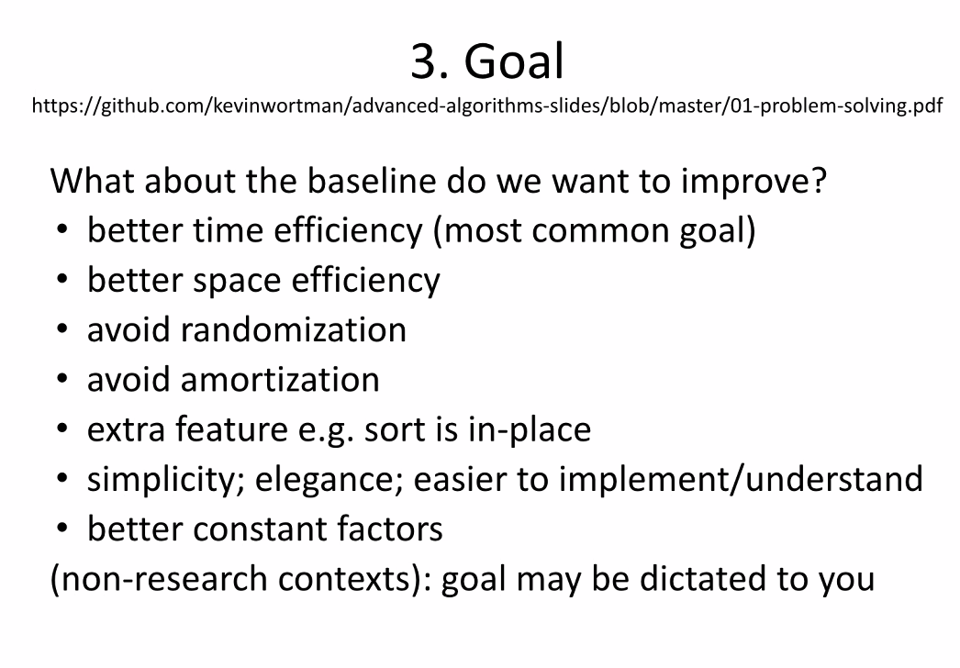
   9. 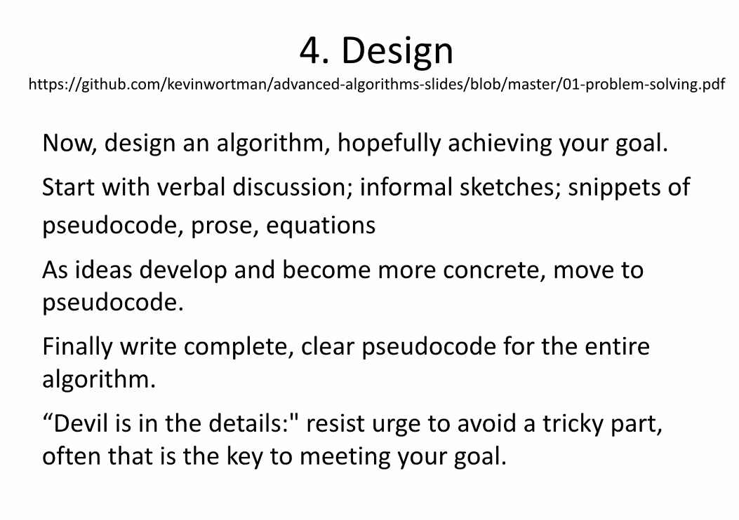
   10. 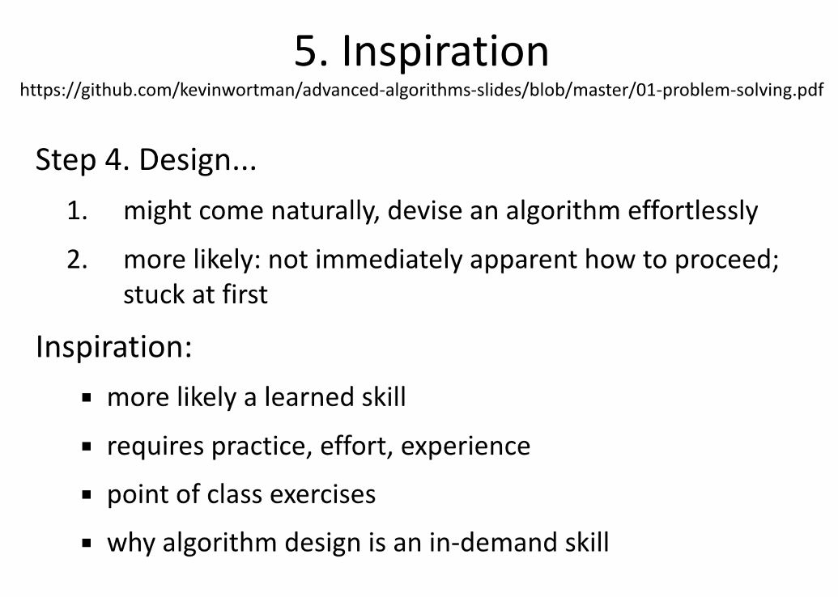
   11. 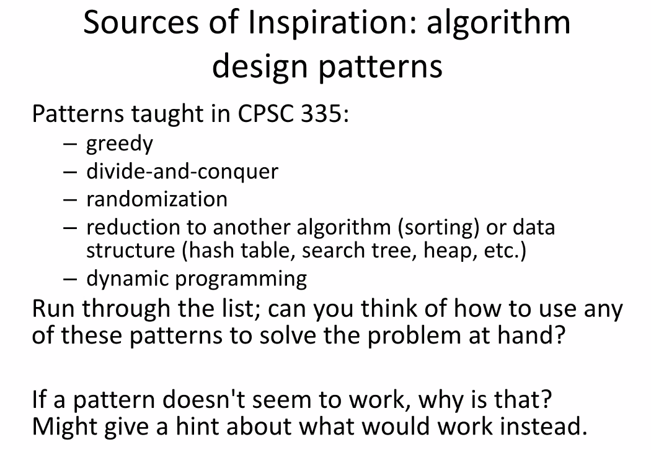
   12. 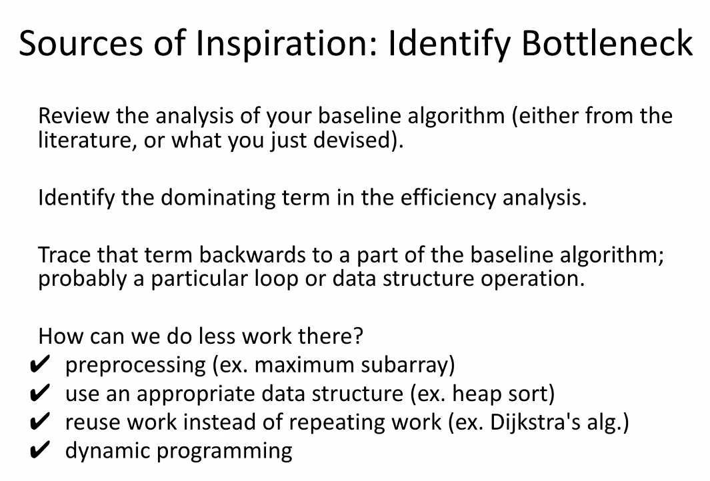
   13. 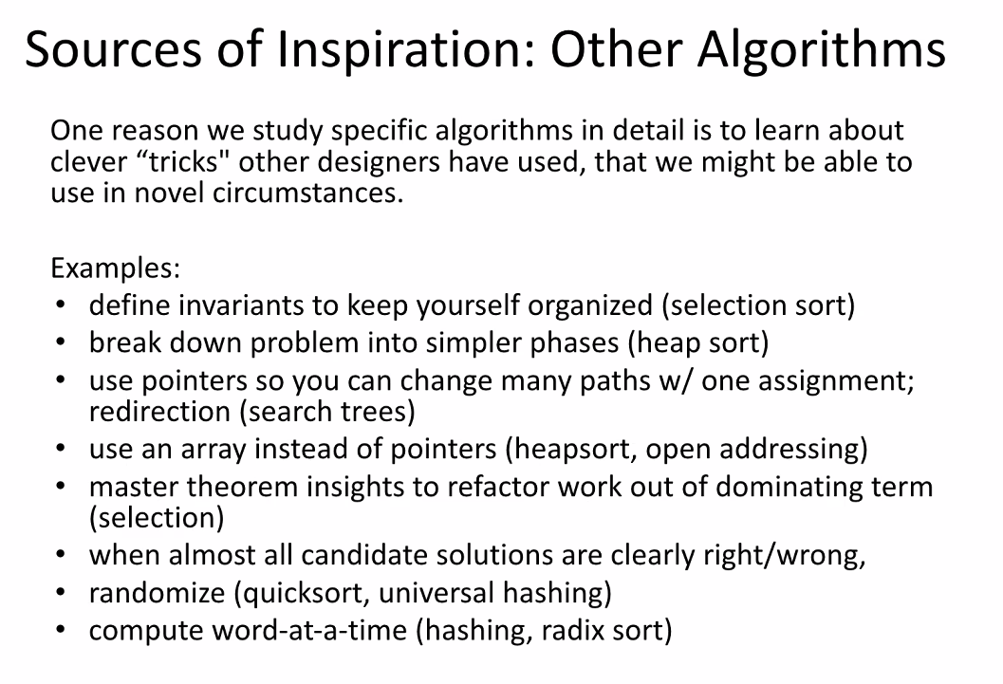
   14. 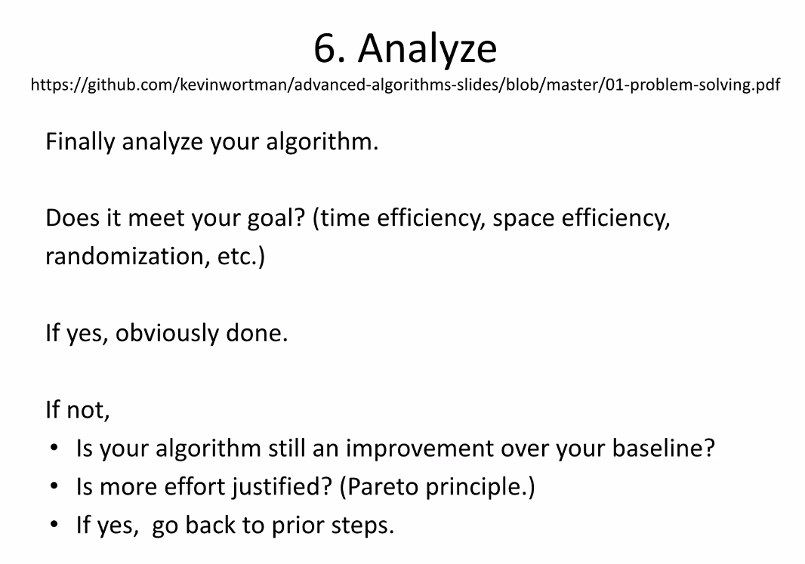
7. Why don’t processors stop talking about sorting?
   1. 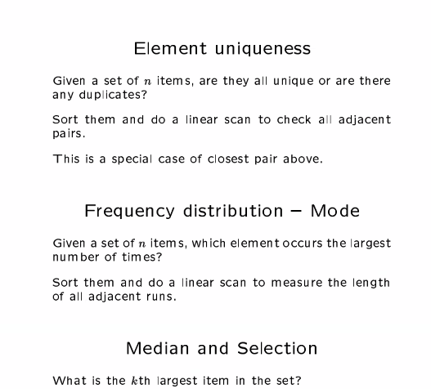
   2. See  
      users.cs.duk.edu/~reif/courses/alglectures/skiena.lecures/lecure4.1.pdf
   3. 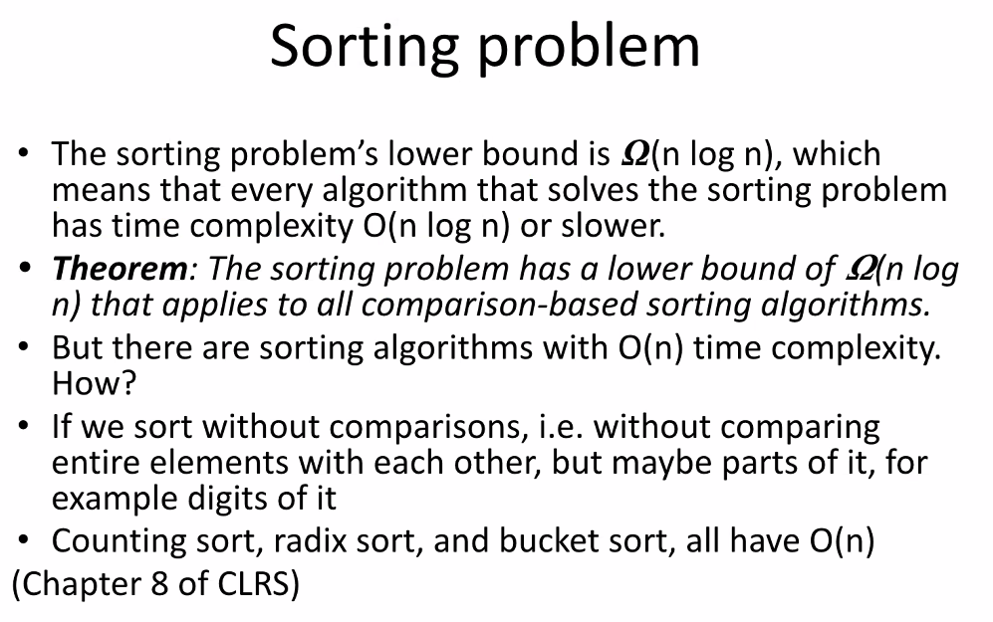
   4. 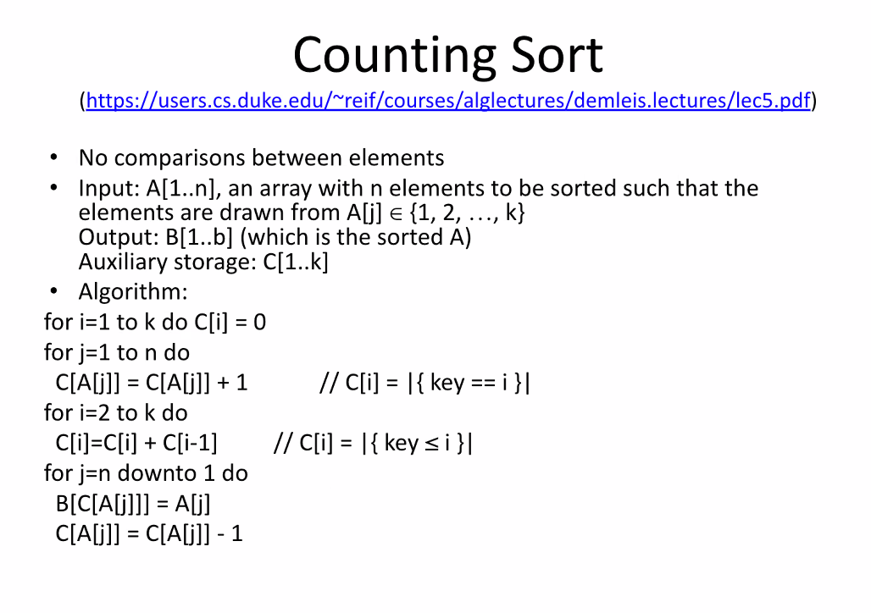
   5. Example: Counting sort
      1. 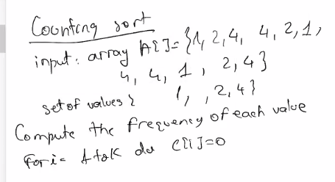
      2. 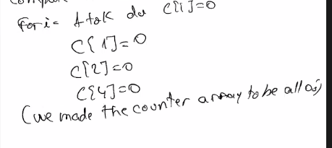
      3. 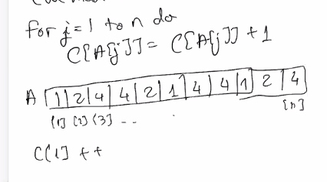
      4. 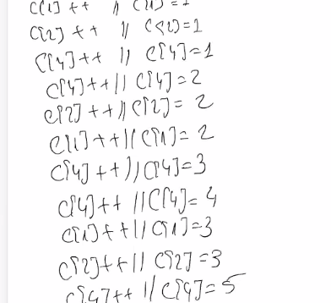
      5. 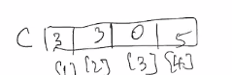
      6. 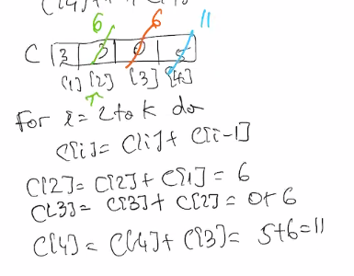
      7. 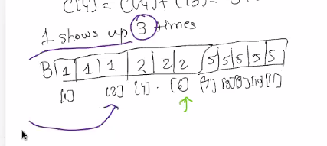
      8. Counting sort will be part of next hw
      9. 